
Join the Friends on Saturday 8th November for a Trip to Launceston Cornwall
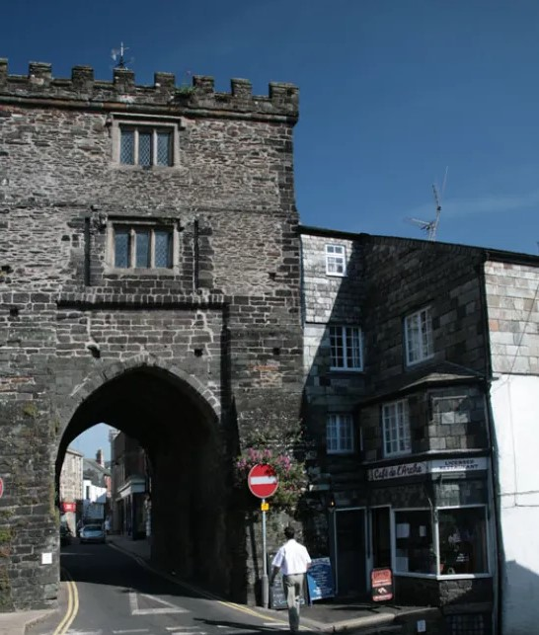
Launceston, nestled in northeast Cornwall, is a historic market town often called the "gateway to Cornwall" due to its proximity to the A30. Dominated by the imposing Norman Launceston Castle, built around 1070, the town boasts steep hills, medieval architecture, and charming Georgian streets. Once the county town of Cornwall until 1835, it retains a rich heritage with remnants of defensive walls and a 14th-century gatehouse. The town supports a vibrant local community with traditional shops, markets, and cultural sites like Lawrence House Museum. Surrounded by scenic countryside, Launceston offers access to Bodmin Moor and the Tamar Valley. It’s also the birthplace of poet Charles Causley, whose legacy adds literary charm to this picturesque and historically significant town
===========================================================================
Excursion Details; Pick up outside Churston Library – 8.30 Depart – Launceston 16.30
Price for members £30 – Non-members £32
Cancellations require 1 weeks’ notice
Applications to reach us no later than October 9th

Launceston 8th November

Number of People--------------------Membership Numbers------------------------------------------------
I enclose Cheque/Cash to the value of------------------------------------------------------------------------
Please make cheques payable to “Friends’ of Churston Library”
All payments to be left in the Friends’ box inside Churston Library. Please include your name and number in case we need to contact you.
Name-------------------------------------------------------Telephone----------------------------------------------

