
Hestercombe Gardens/ Taunton Saturday 28th March

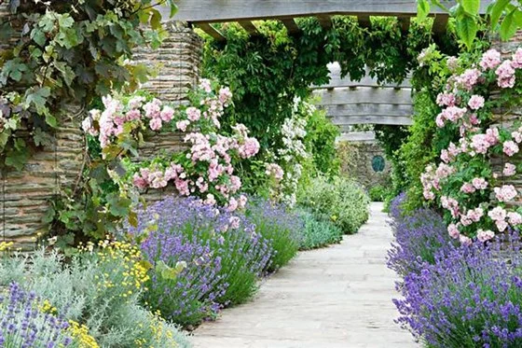
Welcome, Members,
We’re delighted to kick off our first trip of the year with a visit to Hestercombe Gardens. To find out more about the gardens, including opening times and prices, you can visit their website at www.hestercombe.com.
Good news for RHS members — entry to Hestercombe is free with your membership. You can check the details at rhs.org.uk.
For anyone who prefers not to visit the gardens, we’ll also be heading to the nearby town of Taunton, where you can enjoy a lovely mix of traditional market-town charm, independent shops, cafés, and interesting historical sites.
We’re looking forward to a wonderful day out together.
==================================================================
Excursion Details
1st Pick up Brixham Bus Station 8.00 - 2nd Churston Library - 8.20 – Departures 16.30
Price for members £30 – Non-members £32
Cancellations require 1 weeks’ notice
Applications to reach us no later than February 28th

Hestercombe Gardens/Taunton 28th March

Number of People--------------------Membership Numbers------------------------------------------------
I enclose Cheque/Cash to the value of------------------------------------------------------------------------
Please make cheques payable to “Friends’ of Churston Library”
All payments to be left in the Friends’ box inside Churston Library. Please include your name and number in case we need to contact you.
Name-------------------------------------------------------Telephone----------------------------------------------
There are no refunds for cancellations exceeding the week period

