
Join the Friends on a day out to Weymouth on Saturday 12th July

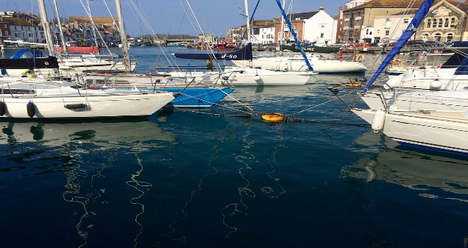
Weymouth, a charming seaside town in Dorset boasts golden beaches, a historic harbour, and a vibrant atmosphere. Nestled along the Jurassic Coast, it is renowned for its stunning coastal scenery and rich maritime heritage. The town played a key role in the 2012 Olympic sailing events, highlighting its strong nautical connections. Weymouth Beach, with its soft sand and traditional Punch and Judy shows, draws visitors year-round. The picturesque harbour features colourful houses and bustling waterfront restaurants, making it a perfect spot for relaxation. Nearby, Nothe Fort offers a glimpse into the town’s military past, while the Isle of Portland adds dramatic landscapes. With fresh seafood, charming shops, and scenic coastal walks, Weymouth is a quintessential British seaside destination.

Price – Members £30 – Non-members £32
Pick up point - Churston Library – Departure 8.30am
Applicants to reach us no later than 30th June to avoid any disappointments
Churston Library would appreciate it if people arriving by car would not use the library car park as this is for library users only. The staff thank you in advance for your co-operation
--------------------------------------------------------------------------------------------------------------------------
WEYMOUTH SATURDAY 12TH JULY
Number of people---------------- Friend’s membership number(s)---------------------------------------
I enclose Cheque/Cash to the value of------------------------------
Please make cheques payable to ‘Friends 0f Churston Library’
All payments can be left in the Friends box inside Churston Library. Mark envelope Weymouth. Please give details of name and number in case we need to contact you.
Name(s)----------------------------------------------------Telephone-------------------------------------------

